Ideation Phase
Empathize & Discover

Date
Team ID | 6aba08748343c5cff062c252
Project Name | PocketSmart AI: Your Smart Budget & Recommendation Assistant
Maximum Marks

Empathy Map Canvas:
An empathy map is a simple, easy-to-digest visual that captures knowledge about a user’s behaviours and attitudes.
It is a useful tool to help teams better understand their users.
Creating an effective solution requires understanding the true problem and the person who is experiencing it. The exercise of creating the map helps participants consider things from the user’s perspective along with his or her goals and challenges.
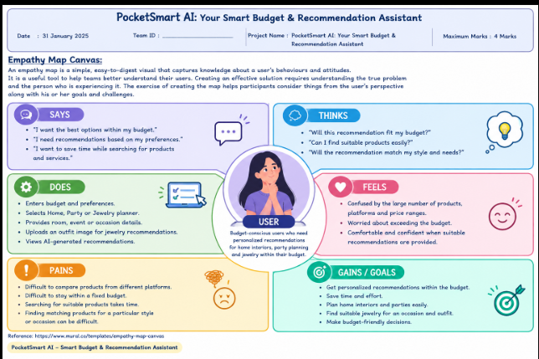

SAYS
- “I want the best options within my budget.”
- “I need recommendations based on my preferences.”
- “I want to save time while searching for products and services.”

THINKS
- “Will this recommendation fit my budget?”
- “Can I find suitable products easily?”
- “Will the recommendation match my style and needs?”
DOES
- Enters budget and preferences.
- Selects Home, Party, or Jewelry planner.
- Provides room, event, or occasion details.
- Uploads an outfit image for jewelry recommendations.
- Views AI-generated recommendations.
FEELS
- Confused by the large number of products, platforms, and price ranges.
- Worried about exceeding the budget.
- Comfortable and confident when suitable recommendations are provided.
PAINS
- Difficult to compare products from different platforms.
- Difficult to stay within a fixed budget.
- Searching for suitable products takes time.
- Finding matching products for a particular style or occasion can be difficult.
GAINS / GOALS
- Get personalized recommendations within the budget.
- Save time and effort.
- Plan home interiors and parties easily.
- Find suitable jewelry for an occasion and outfit.
- Make budget-friendly decisions.

